**Barrie Rugby Club**

**Adult Rugby Kit Sizing Guidelines**

|  |  |  |  |  |  |  |  |  |
| --- | --- | --- | --- | --- | --- | --- | --- | --- |
|  | BASIC MEASUREMENTS - Adult Shorts | | | | |  |  |  |
| (in Inches) |  |  | Adult |  |  |  |  |  |
|  | XS | S | M | L | XL | 2XL | 3XL | 4XL |
| Flat Waist Length | 12 | 13 | 14 | 15 | 16 | 17 | 18 | 19 |
| Inseam Length | 3 5/8 | 3 7/8 | 4 1/8 | 4 3/8 | 4 7/8 | 5 1/8 | 5 3/8 | 5 5/8 |
| Waist Circumfrence | 29-31 | 31-33 | 33-35 | 35-37 | 37-39 | 39-41 | 41-43 | 43-45 |

|  |  |  |  |  |  |  |  |  |  |  |  |
| --- | --- | --- | --- | --- | --- | --- | --- | --- | --- | --- | --- |
|  | BASIC MEASUREMENTS – TRAINING SHIRT | | | | |  |  |  |  |  |  |
| (in Inches) |  | Youth |  |  |  | | Adult |  |  |  |  |
|  | S | M | L | XS | S | | M | L | XL | 2XL | 3XL |
| Front Body Length | 23" | 24.5" | 26" |  |  | |  |  |  |  |  |
| Chest Width | 17" | 18" | 19" | 20" | 21" | | 22" | 23" | 24" | 25" | 26" |
| Chest Full | 34" | 36" | 38" | 40" | 42" | | 44" | 46" | 48" | 50" | 52" |

**How to order your rugby kit**

Immediately after you have paid your registration fee through the online registration website please complete the Kit Ordering Form below and email it to our Kit Manager Travis MacIver at equipment.order@barrierugbyclub.com . Your kit should last a few seasons. You need to register and order the kit before May 25, 2017 or we cannot guarantee you kit that fits properly by the first game of the season.

**Barrie Rugby Club kit policy**

Every player’s initial registration fee with the Barrie Rugby Club Adult Program, consisting of Men’s and Women’s, includes a free training shirt, game shorts and socks. After this initial free kit is provided players will be required to pay for any replacement kit at their own expense, this can be ordered and paid for through our Kit Manager. The playing kit we provide is highly durable so you should be able to get a few seasons play from it. As of 2017 a replacement training shirt and game shorts currently costs approximately $70 but this may be subject to change. Socks are provided as part of the kit.

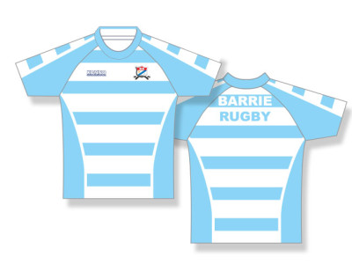

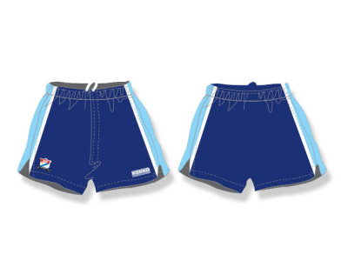

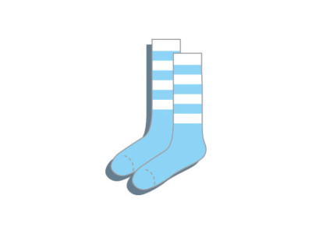

**PLEASE RETURN JUST THIS PAGE COMPLETELY FILLED IN**

**Barrie Rugby Club Kit Order Form**

Please circle shirt and short size required

|  |  |  |  |  |  |  |  |  |  |  |
| --- | --- | --- | --- | --- | --- | --- | --- | --- | --- | --- |
| RUGBY SHIRTS | YS | YM | YL | AXS | AS | AM | AL | AXL | A2XL | A3XL |
|  |  |  |  |  |  |  |  |  |  |  |
| RUGBY SHORTS | YXS | YS | YM | YL | YXL | AS | AM | AL | AXL | A2XL |
|  |  |  |  |  |  |  |  |  |  |  |

PLAYERS FULL NAME _________________________________ EMAIL ___________________________________

SIGNATURE __________________________________ PHONE _________________________________

MENS OR WOMENS? _________________________

HAVE YOU EVER PLAYED FOR THE BARRIE RUGBY CLUB BEFORE? YES or NO

PLEASE COMPLETE THIS FORM AS SOON AS YOU HAVE PAID TO REGISTER ONLINE AND EMAIL IT TO OUR KIT MANAGER TRAVIS MACIVER AT equipment.order@barrierugbyclub.com. IN ORDER TO GET YOUR KIT ON TIME AND ACCURATELY SIZED YOU NEED TO REGISTER AND ORDER YOUR KIT BEFORE May 25, 2017 OR WE CANNOT GUARANTEE HAVING APPROPRIATE KIT FOR THE FIRST GAME OF THE SEASON.

